LAB #12

Introduction to Simulink in MATLAB



Spring 2023

**CSE-301L Signals & Systems Lab**

Submitted by: MUHAMMAD SADEEQ

Registration No.: 21PWCSE2028

Section: C

“On my honor, as a student of the University of Engineering and Technology, I have neither given nor received unauthorized assistance on this academic work”

Submitted to:

Engr. Sumayyea

(6 June 2023)

Department of Computer systems engineering

University of Engineering and Technology, Peshawar

**OBJECTIVES OF THE LAB**

**What is Simulink?**

* Simulink is an extension to MATLAB. In Simulink, you build block diagram models of dynamic systems instead of text code. It is easy to model complex nonlinear systems. Simulink can model both continuous and discrete-time components.

**---------------------------TASK 1 ---------------------------**

* Design any signals and systems example in Simulink.
* Let I take a half wave rectifier.
* **HALF WAVE RECTIFER:**

**Circuit Diagram:**

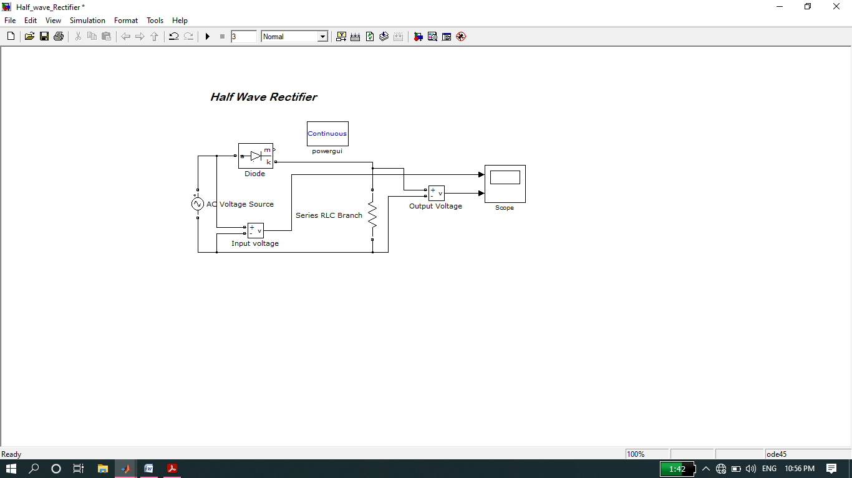

**Graph:**

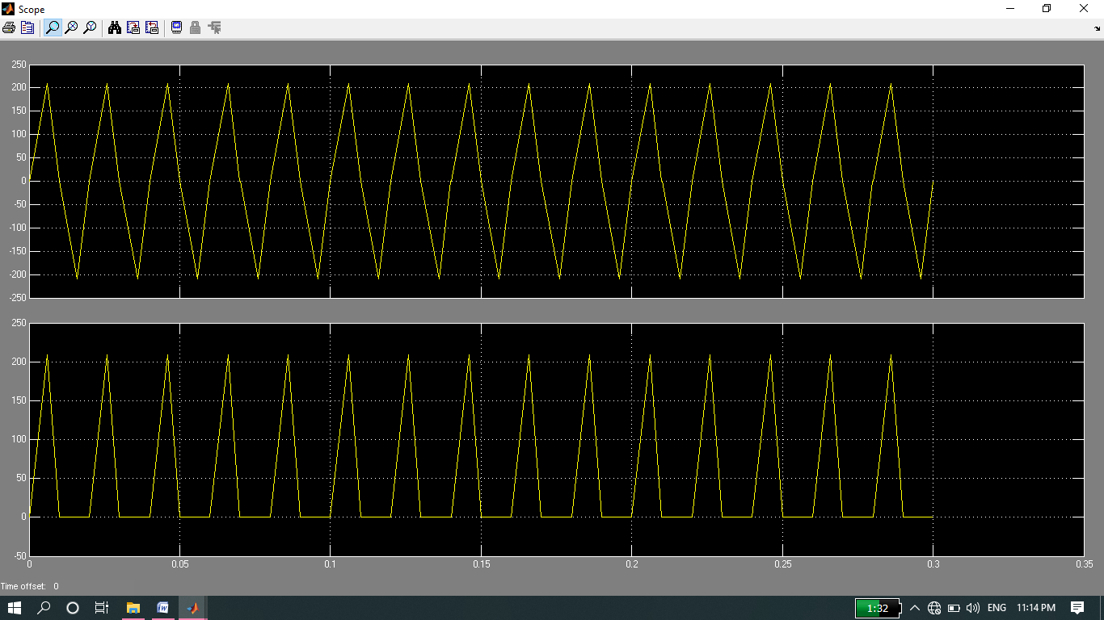

* **Now implementation of above circuit through coding in MATLAB:**

**Code:**

|  |
| --- |
|  |
|  |
|  |
|  |
|  |
|  |
|  |
|  |
|  |
|  |
|  |
|  |
|  |
|  |
|  |
|  |
|  |

**Graph:**

